**A Report From The ‘In The Trenches’ Series**

**“Solved - What To Actually *Do* To Start Earning From Your Online Business”**

By Tony Shepherd

All Rights Reserved © Hippy Marketing/Tony Shepherd

**NOTICE: Sorry But You Do NOT Have the Right to Reprint or Resell this Report!**

**You Also MAY NOT Give Away, Sell or Share the Content Herein**

ALL RIGHTS RESERVED: No part of this publication may be transmitted, reproduced or copied in any form whatsoever, electronic, mechanical, including photocopying, faxing, recording or by any information storage or retrieval system without the express permission (written, signed and dated) of the author(s).

DISCLAIMER AND/OR LEGAL NOTICES:  
The information presented herein represents the view of the author as of the date of publication.

Because of the rate with which conditions change, the author reserves the right to alter and update his opinion based on the new conditions. The report is for informational purposes only. While every attempt has been made to verify the information provided in this report, neither the author nor his affiliates/partners assume any responsibility for errors, inaccuracies or omissions.

Any slights of people or organisations are unintentional. If advice concerning legal or related matters is needed in any way connected with this publication, the services of a fully qualified professional should be sought. This report is not intended for use as a source of legal or accounting advice in any way. You should be aware of any laws which govern business transactions or other business practices in your country and/or state. Any reference to any person or business whether living or dead is purely coincidental.



Tony Shepherd here…

Here is a strategy for anyone who has never made any money online, or isn’t yet making very much OR wants to take their earning to a level where it starts to approach their salary.

It’s for those at ‘floor level’ who want to ride the lift a bit higher.

I’m going to show you how the internet is just *waiting* for you to give it a gentle nudge and take advantage of the earning and freedom potential you see around you but maybe aren’t part of just yet.

These strategies will require some work from you. That’s because *they* actually work, as you’ll find out :)

**Let’s dive in…**



Yorkshire, UK

**You - The Expert, Results-Based Best-Selling Product Creator.**

(But in a more effective way than you’ve maybe come across before!)

**

This changed my life…

It’s what I do for a living and have done for the past ten years.

And for you?

Well as I said, it’s life-changing, the quickest way to as much wealth as you want, and anyone can do it with a slight shift in mindset and a little work.

But first…

**Just Stay With Me, Even If You Don’t Want To Be A Product Creator Because I’m Going To Show You How To Do It Easier And More Profitably Than You’ve Ever Seen Before ;)**

Here’s the crux of the matter:

**People Pay To Hear How Others Have Achieved Specific Results.**

(If you’ve not had any results yet don’t worry, I expected that and I’ve got it covered)

**People will pay much more to hear about actual results than they will about theory or research.**

So if you research and write an ebook about how to make money using Bing ads and put it into a resource you might sell a few copies.

But if you **go out there** and spend $20 on Bing ads, and make $80 in profit, then do it again in a different niche, suddenly you have a system that has a LOT of value and it’s only cost you $40 and some time.

You can write it up, along with earnings screenshots then either launch it yourself, or easier if you don’t have a list you can contact one of the WSO

launchers who send you emails every day, tell them you have a proven system and partner on a launch with them.

They do the whole site building launchy thing, you bring the product and you split the dosh at whatever percentage you agree on.

*I’m getting ahead of myself and you’re getting worried that you have to actually make some money to have something to write up before you can sell it, right?*

Don’t worry, it’s nowhere near as hard as you might think.

I’ll give you a couple of real life examples soon, but in the meantime get your head around the fact that **creating products based around your own results (or the results of others you can leverage) will give you unique products.**

It’s all about the specifics.

You shouldn’t sell *‘Make money with Bing ads’*

You SHOULD sell *‘How to turn $20 into $80 with Bing ads as often as you like’*

Because the second one will sell with very little work.

Look at the titles of a few of my free reports below:



See how they mostly deal with *Specifics?*

*Numbers, time scales etc…*

You’re naming RESULTS.

Numbers, amounts, specifics.

**And that’s what sells BY FAR the best in most online niches**.

It sells in the dating niche:

It’s the difference between: *“How to sleep with more women”*

And: *“How to sleep with three different women every week by adding just one line to your online dating profile”*

Or in the weightloss niche the difference between:

*“How to lose weight by cutting back on certain foods”*

And: *“Lose 40 pounds in 40 days by taking just THREE items OFF your menu starting today”*

**Specifics.**

Now here’s the good news.

See that screenshot again? (below)

Some of those results aren’t even MY results!

If you subscribe to my [wonderful amazing newsletter](http://www.licensedtoquit.com), as many of you do (thanks), and many *name marketers* do TOO…

…you’ll already know that many, many of the case studies (specific figures included) that I share with you **aren’t even my results!**

They’re fascinating, valuable, insightful and incredibly educational, but they’re not things I’ve done myself.

So let me ask you this:

**How Come I Can Use Other People’s Results And Make Hundreds Of Thousands Doing So But You Feel You Can’t??**

It’s a load of balls, right?

**Of course you can!!**

If you share valuable information and look after your readers, then you can share specific results which will help them and they’ll love you for it, even if they aren’t your own results!

Be honest, be up-front and you’ll make money from it.

So let’s back up a little and I’ll share with you the two ways to do this…

First off you need a little self-belief.

That’s easy to achieve - just try to genuinely help your readers with everything you do and you’ll feel 100% fine about everything you sell.

*In terms of the actual ‘How To’ process, we’ll cover that in the next chapter…*

**How To Create, Specific, Results-Based Products And Make A Lot Of Money From Them**



‘Specifics’ doesn’t have to mean money, although there’s no doubting that’s one of the best specifics to use because it sells well.

But it can be *any* specific result.

I gave you the example in the weightloss and dating niches earlier right?

So the first thing to do is look at your existing business and analyse ANY results you’ve got so far.

Don’t dismiss anything by thinking it’s not ‘enough’ of a result.

I heard about someone - a newcomer to IM - who made several thousand dollars by sharing how she made just half a dozen or so sales of a big launch as an affiliate, by simply using an image on Facebook that she created herself :)

I think she made around $60 from her affiliate commissions but over $2k from selling the report about how she made that $60! :)

**Purely because people were more than willing to pay to hear how she did it.**

*And what’s even better, they loved her for sharing*.

So what results have you had so far?

Have you made any affiliate commissions?

If so analyse how you got them.

Did you email your list?

If so, what was the email about, how did you angle it?

Was it from a FB ad or banner ad?

Maybe you wrote a blog post or put a link in a report?

Analyse everything you did because no matter how simple it is, I guarantee there are people out there who will PAY you to share it with them.

**You know how I made the biggest ever income boost to my business?**

I added continuity and coaching.

**It took just FIVE WORDS to share that with you.**

But I wrote that info up into a full PDF based product (a report actually), added more detail **and made five figures from it**.

I added coaching (yep, told you it worked) as an option on top of the report and made an additional $13,000 from helping people to do the same.

If you’ve ever found a way to get subscribers onto your list then share your actual squeeze page along with your results.

If you’ve found a way to make affiliate commissions then share the email or blog post that sold them along with your results.

If you’ve secured a ghostwriting gig or design job share how you did it - where you advertised, what your online profile said, and what price you pitched.

Give it a specific title:

*“How I secured my first ghostwriting job from scratch in just seven days!”*

You starting to see *how valuable every tiny result* you’ve ever achieved really is?

Typically when I work with clients on this I find that the main problem isn’t that they haven’t achieved any results, or they can’t go and find some they can use…

**…it’s usually that they can’t shake the belief that what they have to share isn’t important and no one will pay for it.**

This belief is SO wrong.

The cure is easy.

**When you make money from your first *specifics* product you’ll know without a shadow of a doubt that you have just changed your income potential forever.**

But what if you haven’t had any results?

Well I’ll be honest, if you’ve been around IM for any length of time you probably WILL have at least some results you can use.

The difficulty is spotting them and feeling confident that they’re useable.

My advice there would be if you have ANY results at all, create a product and give it a go. You’ll probably be pleasantly surprised.

**But If You Really Feel You Don’t Have Anything You Can Share Though, Here’s How To Get Something Together.**

*Start Googling specific results to find case studies:*

**(This is one of my secret weapons and worth more than ten times the price of this report alone!)**

Google the exact phrase: *“How I made $ online”*

I screenshotted the results I got as I’m writing this:

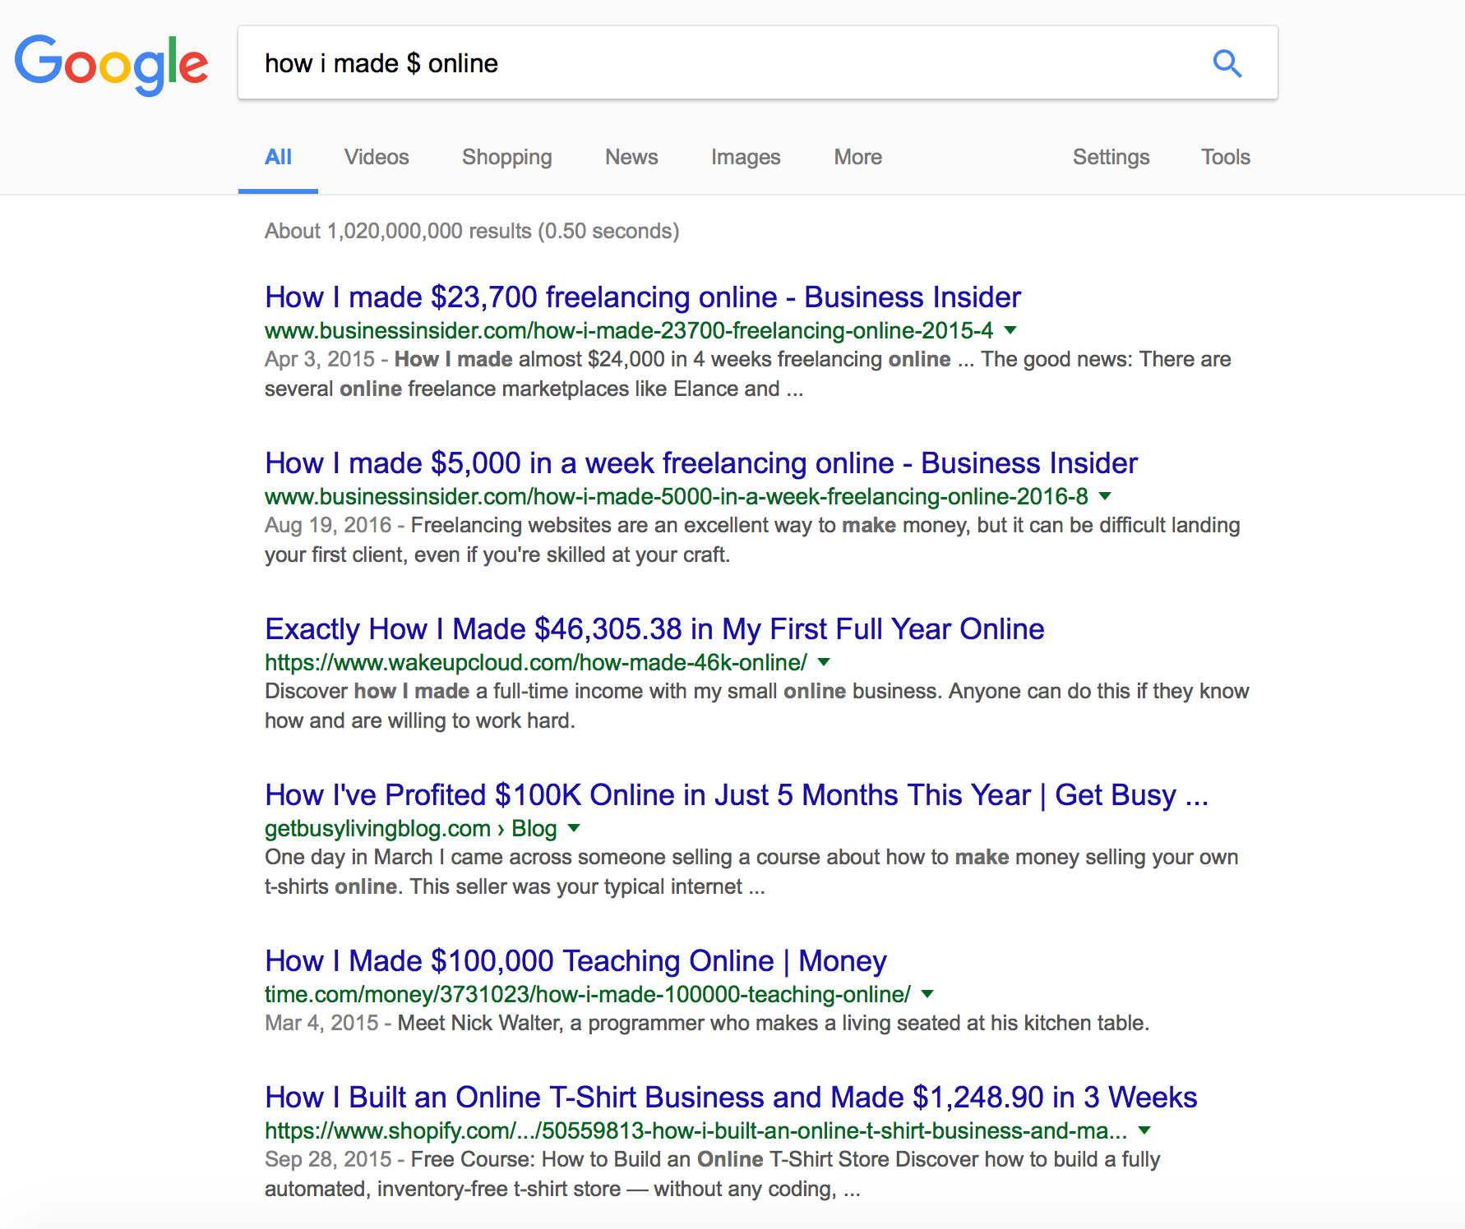

I stopped reading after half a page because the first SIX results are case studies just ready for you to rewrite and run with!

See the shedload of case studies just waiting for you to use?

It goes on and on.

There are PAGES of these.

Just modify your search term to suit your niche and you’re off.

Then dig deeper

Take a look at the first article in the search results: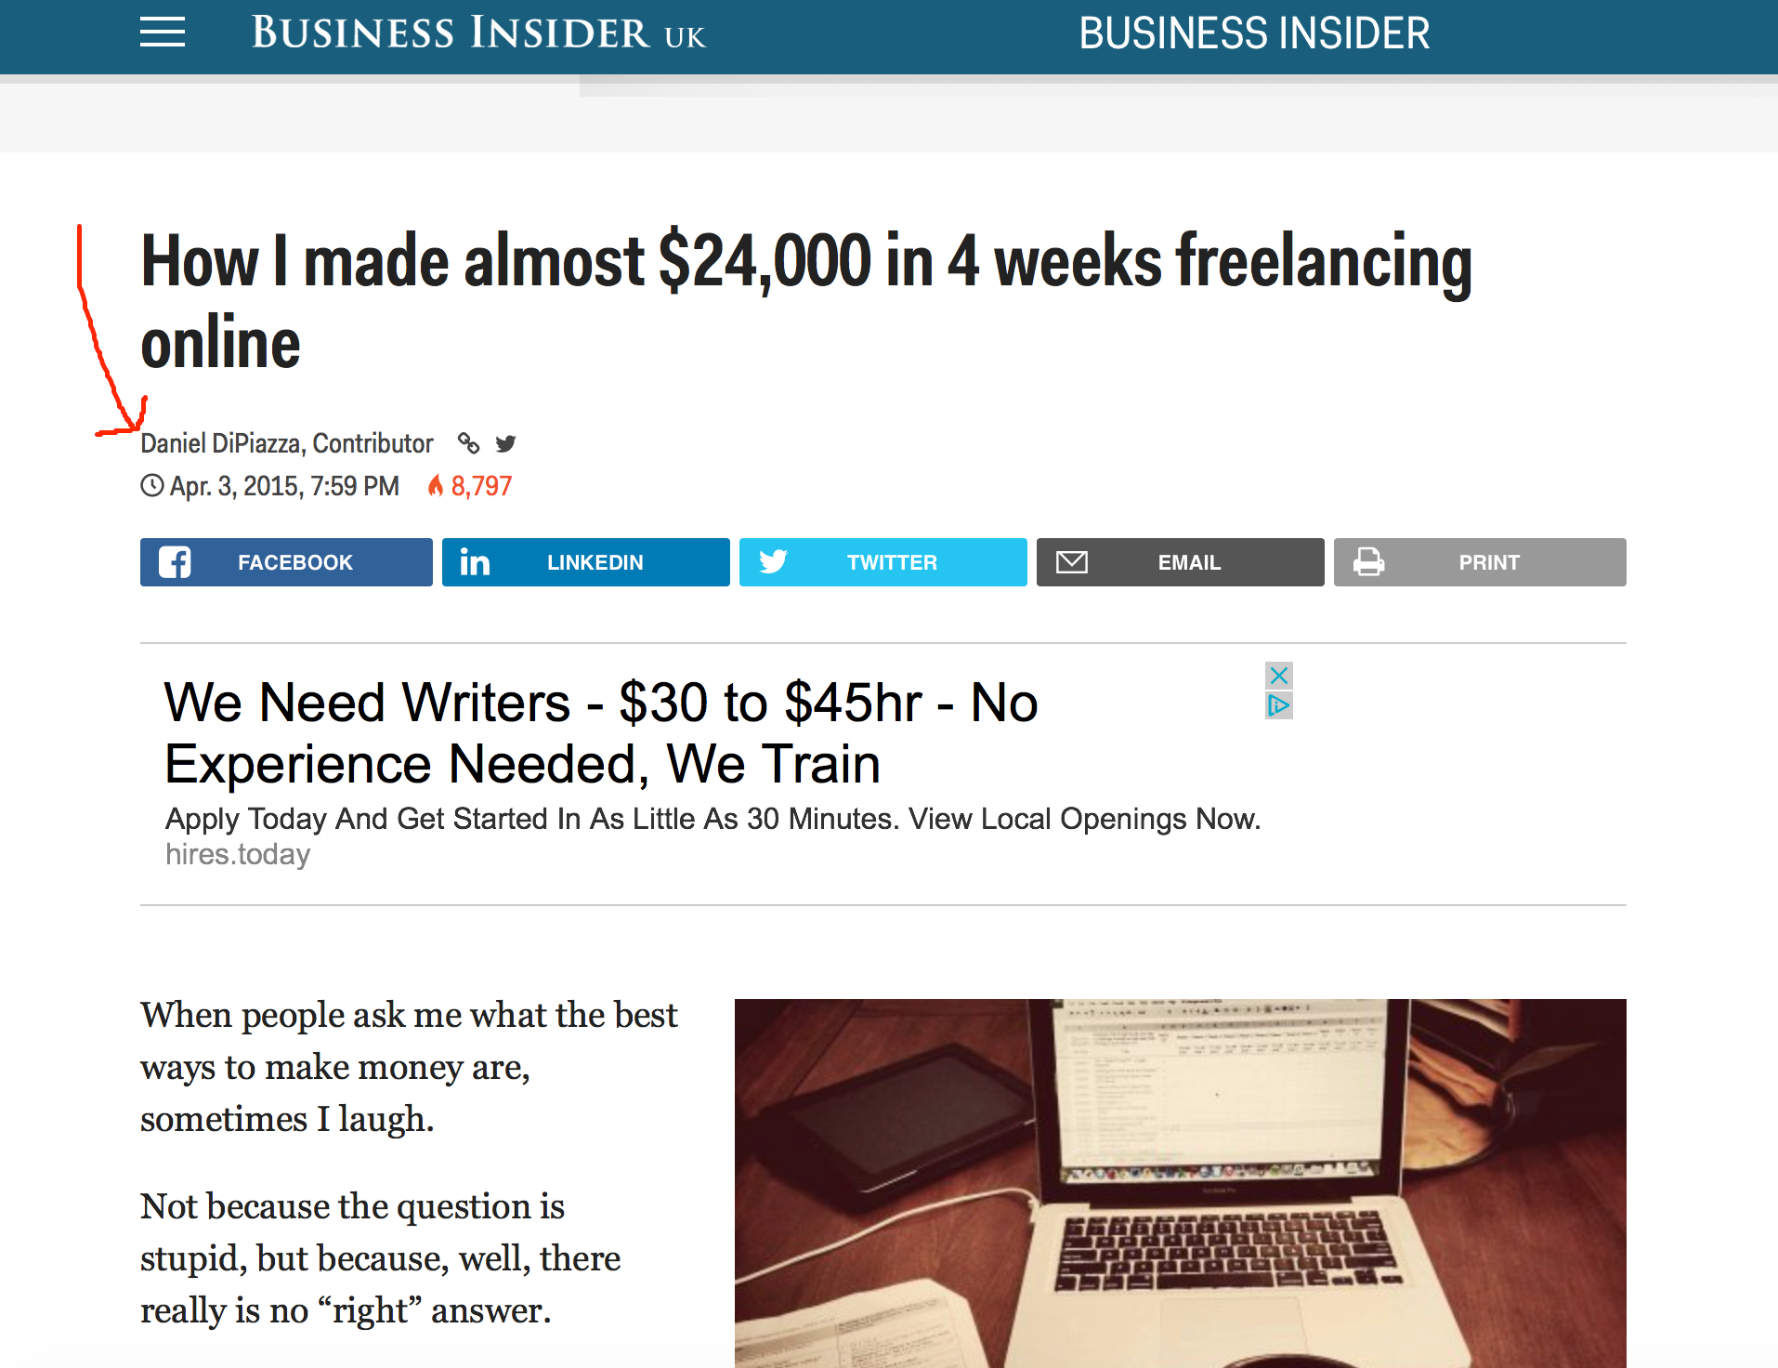

You can see the author’s name (my arrow) and the full method he used is detailed in the blog post.

All you need to do is think basic journalism, credit your sources and start your report with something like:

*“Here’s how Daniel DiPiazza made almost $24,000 in just four weeks freelancing online, as told to the ‘Business Insider’ website.”*

Then rewrite it, although it’s fine to use quotes from the guy himself, again as long as you credit it.

And you have a lovely specific case study.

*Even BETTER, take another couple of results and include those in your product and you’re looking at a seriously good product.*

Now you may think (correctly) that it’s not quite perfect because they’re not your own results.

**BUT…**

**Once you’ve sold a few, you DO have your own results and you can create a case study of how you did it and sell THAT too :)**

It’s just lovely and you’re genuinely helping people at the same time.

And of course once you’ve got your own results things start to move, ideas start to flow, your confidence grows and before you know it you’re making a full-time living from creating *specifics* reports or podcasts or videos.

Let’s move on…

**Your Specific Results Don’t Have To Be About Money!**



In the make money online niche, *how to make money* case studies sell best (obviously), but there are indirect *making money* specifics you can sell that people will happily pay for and that lead to making money.

An example would be the guy who sells *‘The 50 best performing emails subject lines I ever wrote and that got opened more than any others!’*

Or *“The squeeze page headline that got me 50% better opt-in rates than any other”*

Go through your Aweber account and find your best converting squeeze page and analyse your results. Is there anything you can do with this?

Even a three-page report sharing your results gives you a platform to bounce off because you can then share the results you got from selling or giving away THAT report.

**You getting your head around this kind of leverage?**

Creating your own products isn’t as hard as many people think, and there’s no doubt that it opens the gates to as much wealth as you want, depending on how much you want to work.

Look at every single result you get (even if it’s a bad one) because people are willing to pay to know what actually happens in the trenches - what is REAL - and not for theory.

Why do you think I’ve shared ACTUAL results from my own business, from other peoples and given you ACTUAL examples of what to search for and do within the report you’re reading right now?

Because it’s amazing value. **It’s REAL and it’s NOT JUST THEORY.**

Here are more examples…

You know myself and Tony Newton made a shedload of dosh creating plugins and themes a few years back (you should because I mention it a lot LOL)

Well a big part of that income came from **creating products from the RESULTS we got** and offering coaching, courses and products based around those case studies.

**People don’t give a crap that we made six figures selling plugins - they want to know the specifics of HOW we did it so they can do it for themselves.**

Obvious? Yes.

But I see so many people successfully selling plugins, adult colouring books, freelance writing, PLR, niche products, coaching and loads of other stuff…

*…and never thinking to share the specifics of their results and how they do it FOR HUGE PROFITS!*

I’ve said before that every product you sell online is actually TWO (or more) products right?

**The thing you sell, and the product that explains HOW you sold it!**

And again, your readers will ADORE you for sharing it, warts and all.

(And obviously) you can sell your results from those as soon as you get them.

And then there’s this to consider:

**There’s no rule that says you have to do it X number of times before you’re ‘allowed’ to share it or call yourself an expert.**

If you’ve done it, share it, sell it.

Just do it.

You don’t need to ask anyone’s permission.

How many times do you think I added continuity and coaching to my business before I sold the results?

**Once.**

You can only add them once right?

Even if the format changes or you add a *new* continuity - the *idea* of adding it can only happen once. You can add more continuity sure, but the premise itself can only happen once.

Here’s a better example:

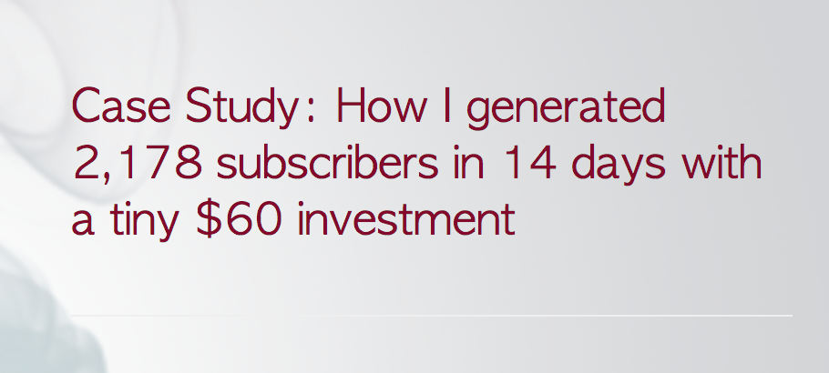

Not directly about making money, but certainly interesting enough for a front-end or even paid product.

and this…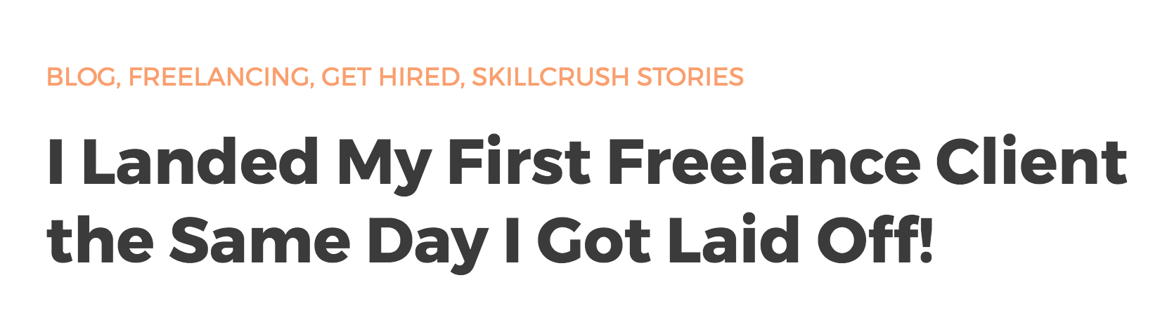

Not directly about money but what freelancer wouldn’t want to read that case study?

So the take-away?

It’s all about getting results then documenting them.

The way to do it is just focus on any and all results you get, and then share them with your readers, as WSO’s, free reports, paid products and so on

**They’ll build your rep, increase your income and get you noticed as someone who actually DOES, rather than someone who talks theory.**

They’ll take from the newbie/wannabe camp into the ‘I’m a marketer’ camp in other people’s eyes. And that opens a lot of doors in terms of JV’s, partnerships and other opportunities.

Here’s how to rise above 90% of wannabe marketers:

**Be an *experience* seller. Not a *theory* seller.**

It doesn’t matter if your results are small either - simply use them to create a front-end product if you’re not confident enough to offer it for sale, ***and then use your results from that to create your next product.***



**WARNING!**

**You MUST Understand The Following If You’re Going To Be Successful In Your Online Business…**

Listen up guys because this isn’t hype.

This **IS** as important as I’m making it appear.

It’s vital you ‘get’ this and adapt your business because of it.

Most people don’t understand this, and this is the second piece of information I’m sharing in this report that is absolutely worth TEN TIMES the price.

This is it:

**The Main Mistake Most Newcomer And Unsuccessful Marketers Make Is They Value Information More Than Experience!**

*But the fact is there is SO much information available on the internet at the moment that is virtually worthless…*

**…UNLESS it’s tied in with personal experience and opinion**.

That’s why you buy my stuff (thank you)

Because I show you **what I’ve done**, **how I did it**, **how much money I made** and give you **my opinion** as to how you can do the same.

**You’re buying my results, opinion and experience.**

**The good news is THAT’S ALL YOU NEED TO DO TO BECOME A SUCCESSFUL INTERNET MARKETER IN WHATEVER NICHE YOU WISH!**

So here’s what you do next…

**Here’s What To Do Next:**



Stay results-focused with everything you do.

Every result you get (and you’ll be getting them almost daily if you’re trying to build an online business) **means something** so write a note about it.

I keep shedloads of notes on everything I do.

Because they’re interesting to other people. Your potential buyers.

In fact **here’s an example of some of my results I put in an email** (below) just a few days ago as I write this. I could easily have built this up into a report by adding screenshots, earnings, more examples, screenshots, advice etc

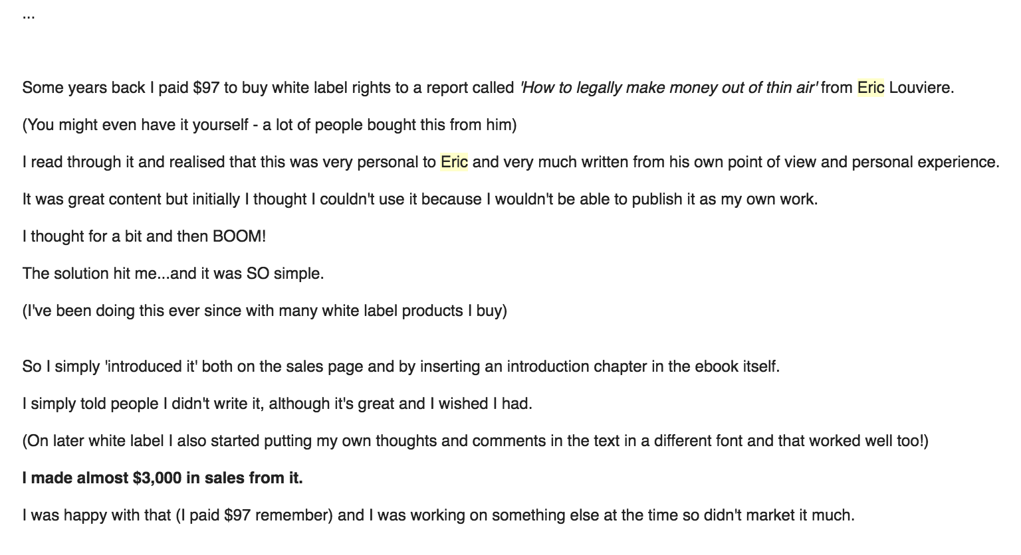

Results, experience, examples and case studies are catnip to internet marketers.

All you have to do is stay focused on delivering them and you’ll develop more results as you go.

With the email above I can also show how my opens increased because I was sharing results rather than just a promo, joke or other content.

Which in turn of course means I got MORE results to show from the results of sharing that email (if you follow LOL - results breed like rabbits!)



**Share Your Negative Results Too!**

Negative results aren’t quite as valuable in terms of selling reports…

But when it comes to getting emails opened, subject lines such as

*‘Well THAT totally bombed’*

or

*‘How I lost $2,786 in one hour’*

will certainly get attention.

It marks you out as an honest person too - a true human being when most of the IM crowd simply pretends to polish their Ferrari and reckon to never put a foot wrong.

Internet marketing these days is no longer a matter of putting a squeeze page up and driving people towards it.

We’re now in the business of building relationships and trust.

And one of the best ways to do that is to share your results, your opinions and to help your readers. Luckily most marketers aren’t yet aware of this and still think it’s just a numbers game.

Their days are limited.

Yours are just beginning :)

Best,



